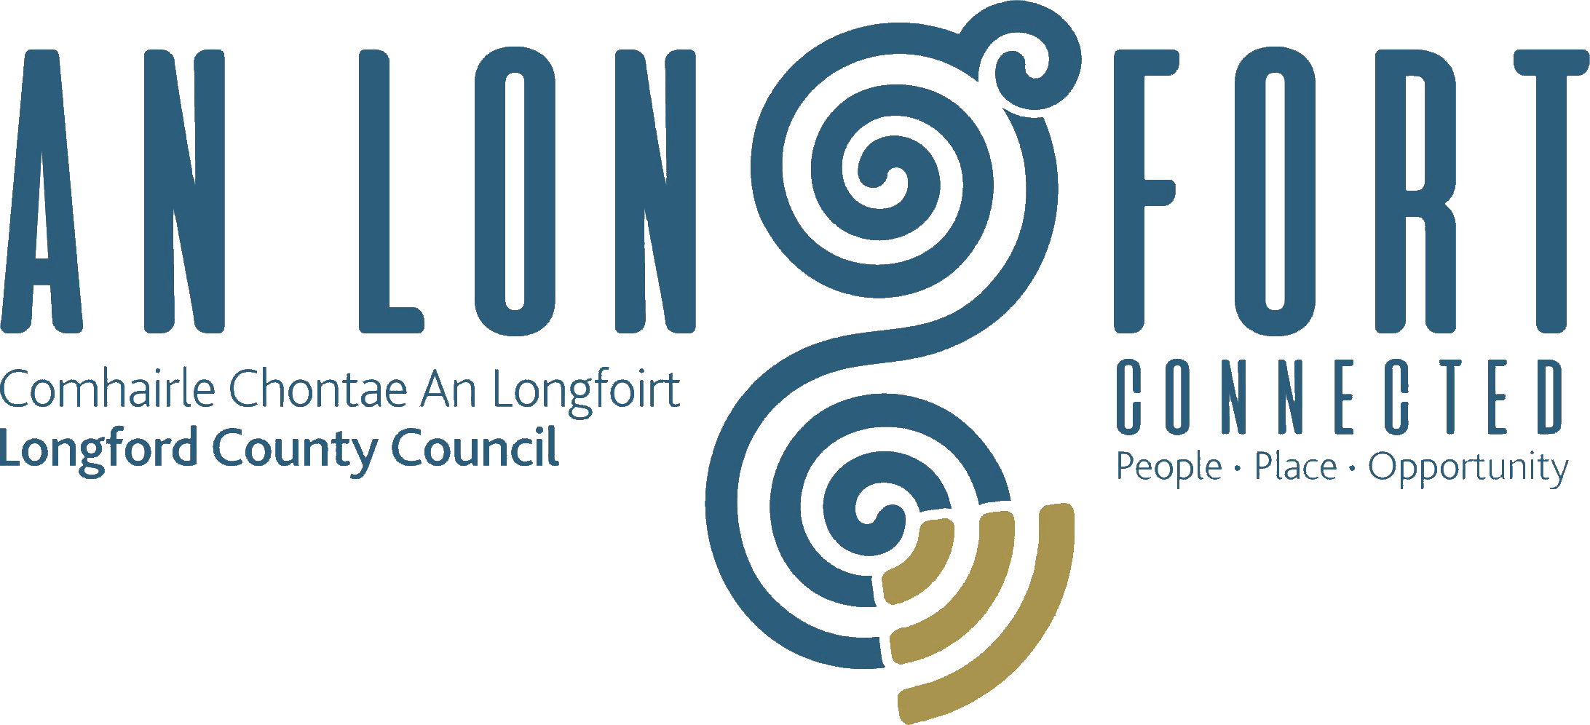

Minutes of Meeting of Longford County Council
held via Microsoft Teams on
Wednesday, 10th February 2021 at 3.00 p.m.

____________________________________________________________________

PRESIDING: Councillor Paul Ross, Cathaoirleach.

MEMBERS PRESENT: Councillors – Paraic Brady, John Browne, Seamus Butler, Mick Cahill, Mark Casey, Colin Dalton, Gerard Farrell,
Gerard Hagan, Martin Monaghan,
Garry Murtagh, Turlough McGovern, Peggy Nolan,
Pat O’Toole, P.J. Reilly, Uruemu Adejinmi and Gerry Warnock.

IN ATTENDANCE: Mr. Paddy Mahon, Chief Executive.
Mr. John McKeon, Head of Finance/Director of Services.
Mr. John Brannigan, Director of Services.
Ms. Barbara Heslin, Director of Services.
Ms. Nora O’Farrell, Senior Executive Officer.
Ms. Ann Marie Mc Keon, Administrative Officer.

Mr. Pat O’Toole, National Broadband Ireland.
Mr. Damien Fitzgibbon, National Broadband Ireland.
Ms. Amy Hanton, National Broadband Ireland.
Mr. Ray O’Sullivan, National Broadband Ireland.

APOLOGIES: Councillor Colm Murray

MEETINGS
ADMINISTRATOR: Anne Lee

PREENTATION BY REPRESENTATIVES FROM NBI (NATIONAL BROADBAND IRELAND)

The Cathaoirleach welcomed Pat O’Toole from National Broadband Ireland.

Pat O’Toole gave a comprehensive presentation. The aim of the programme is to ensure every premises has access to high-speed broadband. DECC identified all premises in the country that don’t have access to high-speed broadband –this is called the Intervention Area or Amber area. NBI have been contracted to build a full fibre network to connect the 544,000+ premises ensuring no one is left behind.
Use existing infrastructure, where possible, to create a sustainable and cost-effective deployment. NBI will utilise latest technology capable of delivering multiples of current demand in traffic and will empower all service providers in Ireland with equal access to a future-proofed wholesale, open access network. Customers to receive option of up to 1Gbps supported from day one with minimum speed of 500Mbps. There are big benefits to High Speed Broadband.
170,000 plus have been surveyed to date & 136,000 plus designs completed. 500 plus premises available for connection in Carrigaline & Cavan Deployment Areas, increasing daily. 35 Retail Service Providers have signed Contracts with NBI to deliver services once the network is built. 113 BCP sites live, plus 31schools. NBI surveyed premises in all 26 counties in 2020. Buildworks will be initiated in all 26 counties in 2021. It’s a seven-year build programme to complete all Looking at opportunities to build faster. Launched first connection in January 2021.

When a premise connects to the internet, the data goes to a Local Exchange. From there the local exchange sends the data to the Regional Exchange. Then the data is sent to Data Centres, this is where to most internet traffic ends up. These are primarily in Dublin.
There are 8,698 premises in County Longford without access to high-speed fibre broadband. Represents 39% of the premises in County Longford. €34m investment in County Longford. NBI will connect Regional Exchanges first. We build out from the Regional Exchanges. Once the Deployment Areas with Regional Exchange in Longford is built, we then spread the build to adjacent Local Exchanges. Survey Complete, now in Design Phase. Estimated date range for connection June 2022 – November 2022. 9 BCP locations & 11 schools are in scope to connect to high-speed broadband. The full list of BCPs is available on www.nbi.ie
Stakeholder engagement will now take place with Local Authorities, An Garda Siochána, Communities and Representatives Bodies.
The members raised several queries which were addressed by Pat. In relation to the connection costs being quoted to enterprise and digital hubs, Pat suggested that these be considered for inclusion on the priority list for Broadband Connection Points.

SUPSPENSION OF STANDING ORDERS-

Final Report of the Commission of Investigation into Mother and Baby Homes.

Cathaoirleach Paul Ross proposed for Standing Orders to be Suspended and Councillor Mick Cahill seconded the proposal. A Joint statement was read out by Councillor Paul Ross and Chief Executive Paddy Mahon in relation to the Final Report of the Commission of Investigation into Mother and Baby Homes. This was followed by a minute’s silence. The members unanimously supported the statement.

ADOPTION OF MINUTES.

On the proposal of Councillor Gary Murtagh seconded by Councillor Pat O’Toole, the Minutes of Monthly Meeting of Longford County Council held on the 20th January 2021, as circulated, were confirmed and adopted.

Land Development Agency Bill 2021.

Councillor Gerry Warnock requested that Standing Orders be suspended to address the provisions of the Land Development Agency Bill 2021 which was published last Friday, Gerry outlined that the proposed removal of the Section 183 reserved function of Elected Members in relation to the disposal of local authority held land to the LDA as provided for in Part 7 Section 56 of the bill is unacceptable and an affront to Local Democracy.

Councillor Paul Ross suggested that Councillor Warnock submit this as a Notice of Motion for the March Meeting. Councillor Warnock agreed. Councillor Mick Cahill also said that, as this is an important national issue, the AILG are also considering the implications of the Bill.

MATTERS ARISING FROM MINUTES.

None.

DECLARATION OF INTEREST BY MEMBERS.

None.

CHIEF EXECUTIVE REPORT.

The Chief Executive Report, as circulated, was noted. The members requested that the Chief Executives Report be circulated a few days before the meeting.

HSE Vaccine Roll Out.

Councillor Peggy Nolan outlined her concerns regarding the rollout of the vaccination programme and that, as yet, no location for a vaccination centre was identified in County Longford. Councillor Nolan proposed that the Cathaoirleach of each Municipal District identify a site in their district and, in conjunction with the Chief Executive, they should make these sites available to the HSE. Concerns were raised about the distance that some may have to travel to centres. The role of pharmacists in the rollout programme was also discussed.

Councillor Mick Cahill said he had received confirmation from the Minister that a centre would be provided in County Longford.

MINUTES OF CORPORATE POLICY GROUP MEETING HELD ON THE
9th DECEMBER 2020 - circulated

The adopted Minutes of Corporate Policy Group Meetings held on the 9th December 2020, as circulated, were noted.

FINANCE & REGENERATION.

Minutes of Meeting of Governance Strategic Policy Committee
The adopted Minutes of meeting of Governance Strategic Policy Committee held on the
20th October 2020, as circulated, were noted.

Local Government Act 2001 - Annual Ethics Declaration.

J. McKeon stated that the closing date for return of Annual Ethics Declaration Forms is Wednesday, 26th February 2021.

Commercial Rates Waiver – First Quarter 2021.
John Mc Keon gave a comprehensive report on the Circular Fin 1/2021 and responded to queries raised by the members.
- In recognition of the impact that COVID-19 is having on businesses a further commercial rates waiver will apply to specified businesses in the first quarter of 2021.
- Scheme applies to businesses closed by, or severely impacted by, Level 5 restrictions announced on 6th January 2021.
- This three-month waiver has modified criteria and accordingly is a separate standalone waiver scheme from the scheme that applied in 2020.
- The waiver will take the form of a credit in lieu of rates and the value is the equivalent of 25% of the annual rate bill for 2021.
- The three-month waiver will apply to all eligible businesses closed by or badly impacted by Level 5 restrictions.
- An application to Longford County Council is not required.
- Longford County Council will automatically apply a 100% credit in lieu of commercial rates, for a three-month period, to classes and categories of occupied rateable property where the occupying business is not in an excluded category.
- The Council are obliged to issue the 2021 Rate Demands to all rate customers.
  - Following the issuing of the rate demands in late February 2021, eligible accounts will have the credit in lieu of commercial rates applied to their accounts to cover the 1st quarter of 2021.
  - The full list of categories and uses of commercial rate properties that are deemed eligible for the Waiver is contained in Appendix C to the circular and will be available at www.longfordcoco.ie
- In recognition of the fact that there may be ratepayers excluded from this waiver that were nevertheless severely impacted by the pandemic, up to 7.5% of the overall €160m national allocation is included for such cases.
- Excluded ratepayers may engage with local authorities to demonstrate severe impact, on a case by case basis.
- Any such customers are advised to e-mail rates@longfordcoco.ie , before Friday 12th March 2021, if they believe that the scheme would apply to them.

COMMUNITY, CORPORATE AND ENTERPRISE.

Adopted Minutes of Placemaking Strategic Policy
The adopted Minutes of meeting of Placemaking Strategic Policy Committee held on the
19th October 2020, as circulated, were noted.

Item referred from Placemaking Strategic Policy Committee Meeting held on the
1st February 2021.

On the proposal of Councillor Seamus Butler seconded by Councillor Gerry Warnock, it was unanimously agreed to adopt the following amendment to the Business Incentive Scheme, as recommended by the Placemaking Strategic Policy Committee –

That the Business Incentive Scheme which was due to expire on 31st December 2020 be extended for another year but only for applications for new industrial/manufacturing type businesses offering additional jobs. An industrial expansion may also be deemed eligible if it moves to a larger unit and results in additional jobs.

STRATEGIC INFRASTRUCTURE AND CLIMATE CHANGE.

Planning Applications.

The lists of Planning Applications received since the last meeting of the Council were noted.

Minutes of Meeting of Climate Action and Planning Strategic Policy Committee
The adopted Minutes of meeting of Climate Action and Planning Strategic Policy Committee held on the 21st October 2020, as circulated, were noted.

Minutes of Meeting of Strategic Infrastructure Strategic Policy Committee.

The adopted Minutes of meeting of Strategic Infrastructure Strategic Policy Committee held on the 22nd October 2020, as circulated, were noted.

Disposal of Property at Carrollbrennan, Newtowncashel, Co. Longford.
On the proposal of Councillor Mick Cahill seconded by Councillor Pat O’Toole, it was unanimously agreed to dispose of property at Carrollbrennan, Newtowncashel,
Co. Longford in accordance with the terms of Section 183 of the Local Government Act 2001 issued on the 26th January 2021, as circulated.

Notices of Motions.

Water Filling Stations.

The following Notice of Motion was proposed by Councillor U. Adejinmi and seconded by
Councillor Seamus Butler -

“I call on the County Council to install contactless water filling stations in all Municipal Districts to limit single use plastic in the County.
The bottle filling stations will provide contactless, clean and safe water without the risk of touching high-use buttons that could increase the spread of infection. Users can simply place a water bottle into the holder and the sensors will pick up on movement and activate the machine.
The units also have digital water flow meters with remote monitoring built in, which monitors the output to determine the amount of plastic water bottles, which have been prevented from entering circulation in the County.
I have discussed this with Longford and Ballymahon Tidy Towns and they have indicated their interest and support for this project.”

J. Brannigan replied that given that it would be a new type of activity for Longford County Council to get involved in, it is recommended that the Notice of Motion be referred to the Placemaking Strategic Policy Committee.

GENERAL

Correspondence – circulated.

Correspondence received from the Office of the Minister for Justice regarding parental alienation was noted.

Retirement.

The members of Longford County Council complimented Administrative Officer Anne Lee and passed on their best wishes to Anne on her upcoming retirement. They welcomed Ann Marie McKeon to the role of Meetings Administrator.

This concluded the business of the meeting.

Anne Lee
Signed: _______________
Anne Lee,
Meetings Administrator.

Confirmed and adopted at Meeting of Longford County Council held on the
10th March 2021.

Paul Ross
Signed: _______________
Cathaoirleach.

